3. Концептуален поглед

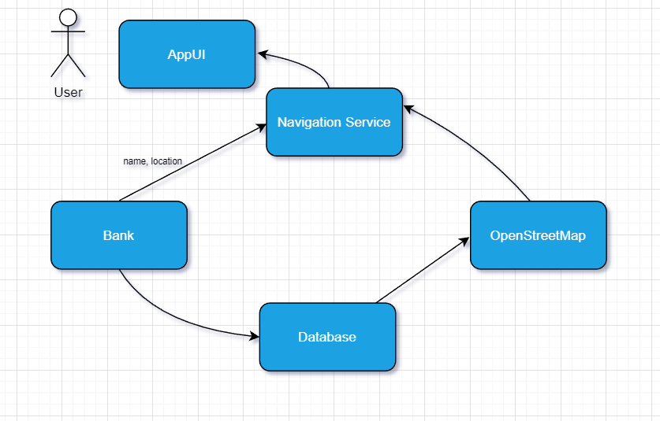

* AppUi
  + Show Places
  + Display Map
  + Display Bank
* Navigation Service
  + Find Bank
* Bank
  + With Properties
  + With ATM
  + Coordinates only
  + With Email
  + With Phone
  + Sort
    - Ascending
    - Descending
  + Limit
    - 10/25/50/100 Banks
    - All Banks
* OpenStreetMap
  + Add Bank
  + Remove Bank